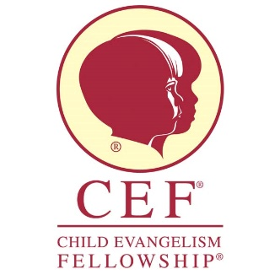
CEF Dallas
Position: Area Coordinator
Reports To: Chapter Director
Type: Hourly Part-Time (20-25 hours per week)
Description: The role of Area Coordinator is to mobilize ministry through Party Club outreach. The ideal candidate will have an evangelistic zeal and deep desire to see children reached with the Good News of Jesus Christ. The Area Coordinator will be an outgoing self-starter who possesses the ability to build new relationship, to establish ongoing ministry partnerships.
Duties to include:
- AREA COORDINATOR
- Area Coordinator will be responsible for an assigned area
- Area Coordinator manages and coordinates Party Club ministry in their assigned area.
- Area Coordinator will be responsible for scheduling 20 party clubs in assigned area per season
  - Daycare Centers
  - Apartments
  - Community Centers
- Parks, Neighborhoods
- Area Coordinator will be responsible for managing church relations in assigned area
- Area Coordinator will be trained to teach Party Club curriculum
- Area Coordinator will develop local Party Club teams/ volunteers to assist with clubs
- Area Coordinators will be responsible to teach the Club if no Volunteer team is available
- Other duties as assigned by the Director

Qualifications:
- Authentic Christian witness and strong Biblical worldview
- 5+ years of evangelistic ministry experience and working knowledge of CEF Club ministry
- Professional appearance and demeanor that demonstrates Christian character
- Excellent organizational, verbal and written communication skills
- Outgoing personality to build relationship with Party Club locations
- Good ability to teach and train volunteers
- Good working knowledge of MS Office
- Must pass Child Protection Policy background check and sign Workers Compliance Agreement
- Must affirm CEF Statement of Faith

